Advance excel Assignment 8

1. AutoComplete helps you quickly insert functions and arguments while minimizing typing and syntax errors. The AutoComplete menu shows you available options based on context, and you choose what you want to insert into your formula.
2. In [Microsoft](https://www.computerhope.com/comp/msoft.htm) [Excel](https://www.computerhope.com/jargon/e/excel.htm), a **workbook** is a collection of one or more [spreadsheets](https://www.computerhope.com/jargon/s/spreadsheet.htm), also called worksheets, in a single file. Below is an example of a spreadsheet called "Sheet1" in an Excel workbook file called "Book1." Our example also has the "Sheet2" and "Sheet3" sheet tabs, which are also part of the same workbook.

In Microsoft Excel, a **cell** is a rectangular box that occurs at the intersection of a vertical column and a horizontal row in a worksheet. Vertical columns are numbered with alphabetic values such as A, B, C. Horizontal rows are numbered with numeric values such as 1, 2, 3.

1. **Fill Handle** is a tool that you can use to autocomplete lists in Excel. You can quickly copy formulas into adjacent cells by using the fill handle. When you drag the handle to other cells, Excel will show different results for each cell.
2. Select the data set. Hover the mouse over the bottom-right edge of the selection, you would see a plus icon appear How to Use Fill Handle in Excel - Plus Icon Small. Click the left button on the mouse and drag it down. Excel identifies a pattern of the first 2 numbers (an increment of 1) and uses that to fill that entire series.

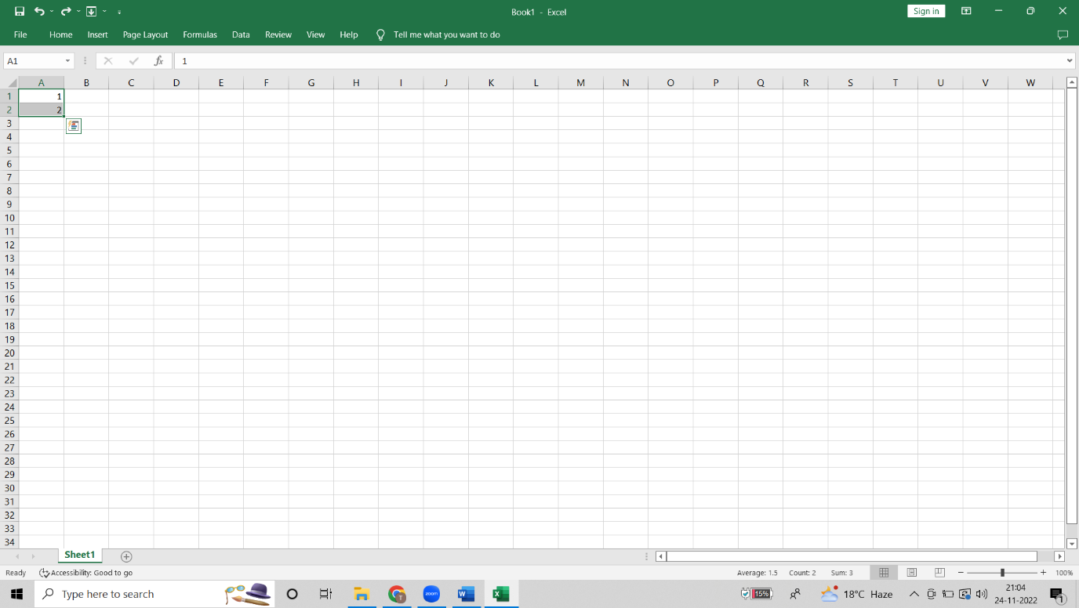

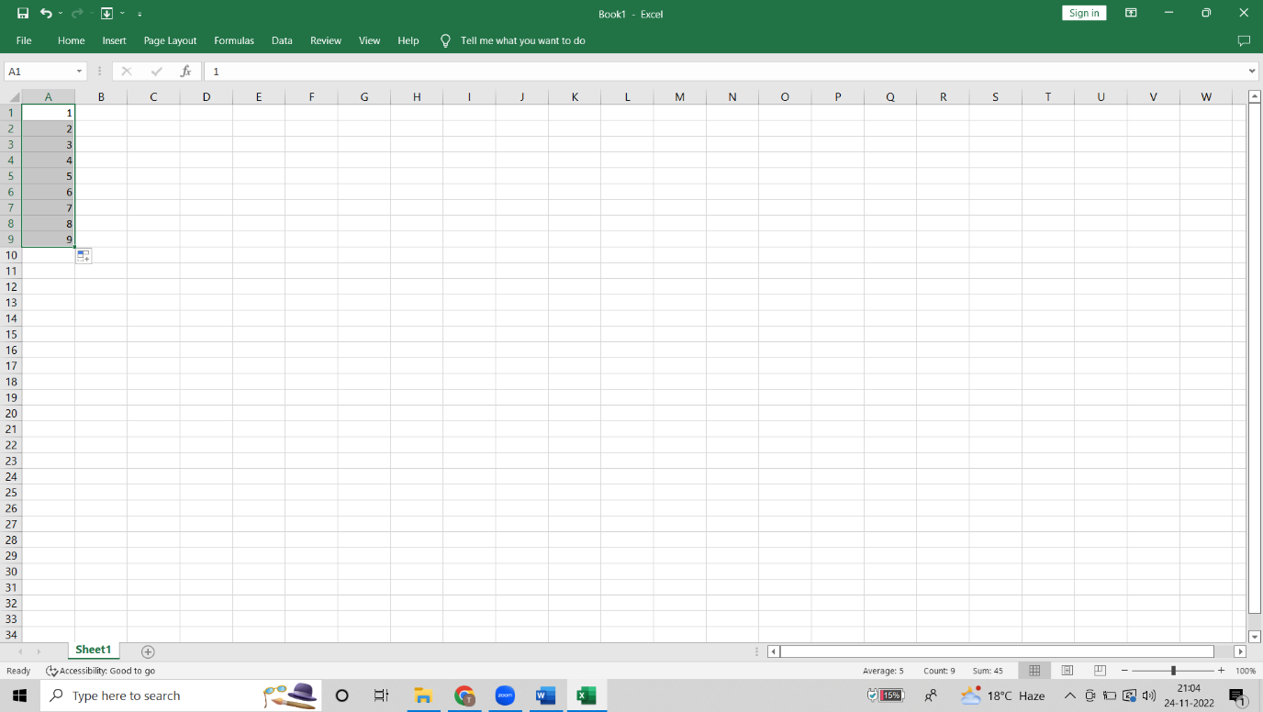

1. Flash Fill automatically fills your data when it senses a pattern. For example, you can use Flash Fill to separate first and last names from a single column, or combine first and last names from two different columns. Click the Flash Fill button on the Data tab or press the  CTRL+E shortcut.

6)

